# AI ASSISTED CODING

## Assignment:-9

### TASK:-1

Task Description#1 Basic Docstring Generation  
• Write python function to return sum of even and odd numbers in the given list.  
• Incorporate manual docstring in code with Google Style  
• Use an AI-assisted tool (e.g., Copilot, Cursor AI) to generate a docstring describing  
the function.  
• Compare the AI-generated docstring with your manually written one

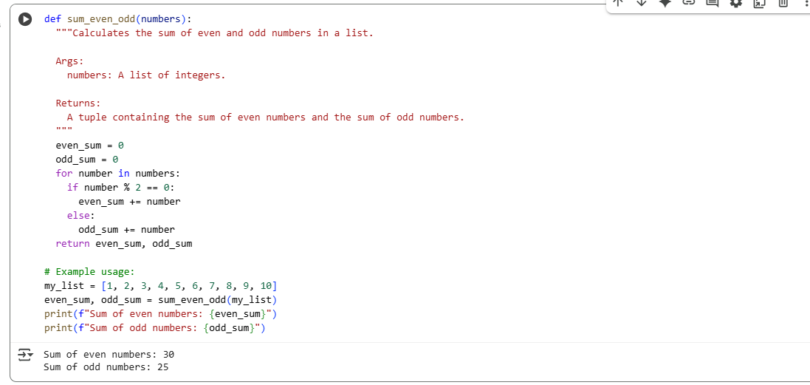

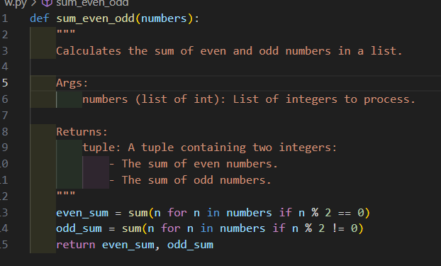

## TASK:-2

Task Description#2 Automatic Inline Comments  
• Write python program for sru_student class with attributes like name, roll no.,  
hostel_status and fee_update method and display_details method.  
• Write comments manually for each line/code block  
• Ask an AI tool to add inline comments explaining each line/step.  
• Compare the AI-generated comments with your manually written one.  
Expected Output#2: Students critically analyze AI-generated code comments

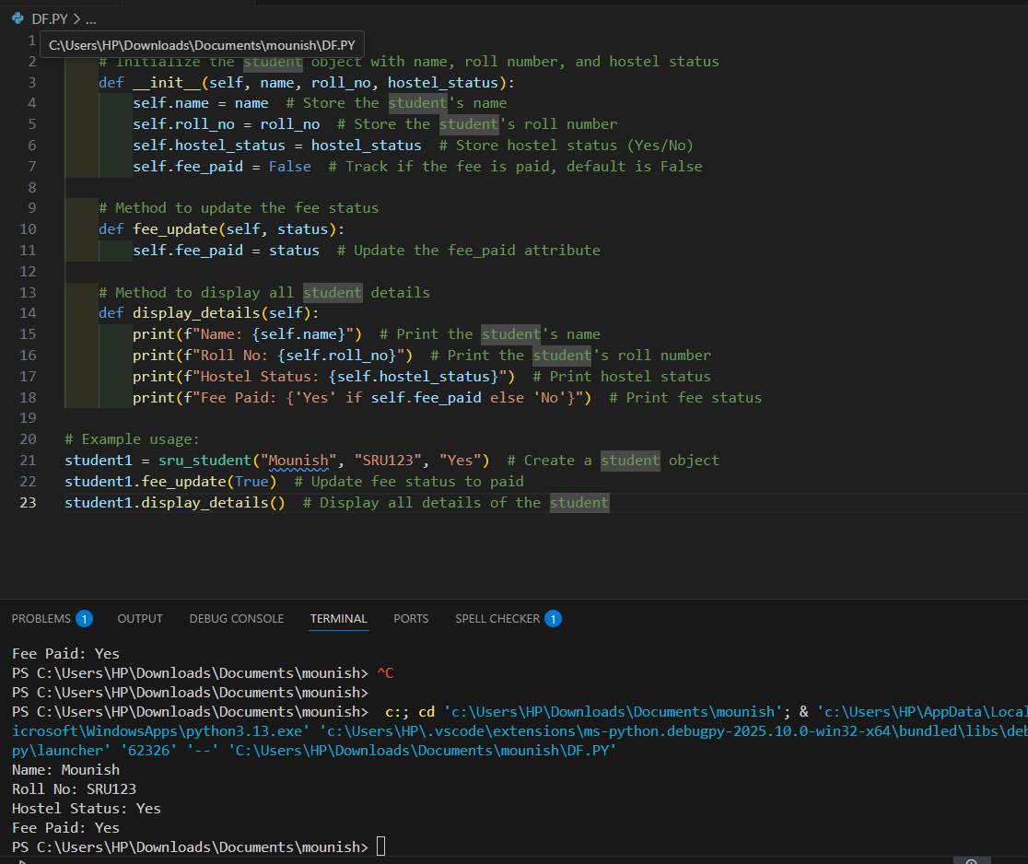

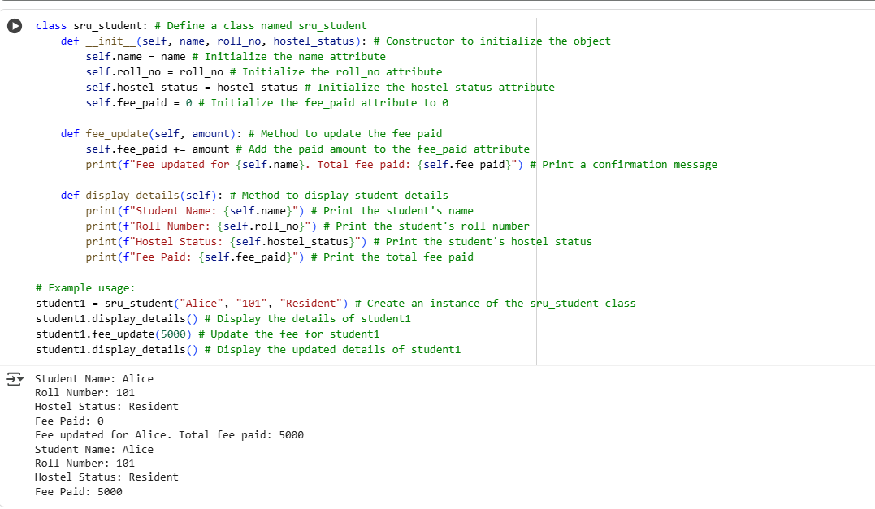

TASK:-3

Task Description#3  
• Write a Python script with 3–4 functions (e.g., calculator: add, subtract, multiply,  
divide).  
• Incorporate manual docstring in code with NumPy Style  
• Use AI assistance to generate a module-level docstring + individual function  
docstrings.  
• Compare the AI-generated docstring with your manually written one.  
Expected Output#3: Students learn structured documentation for multi-function script

